**→ Applications of Autoencoders 🡪Denoising images using custom images :**

**(1) Import some required library :**

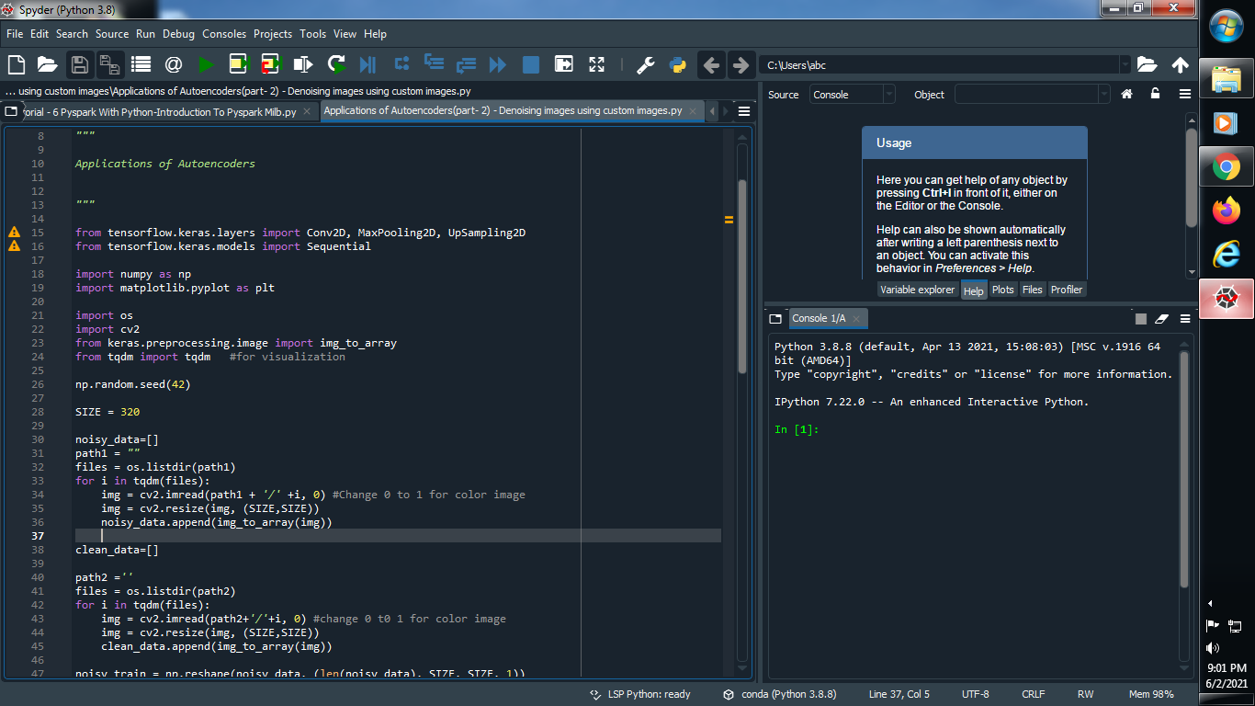

**(2) Define random seed and SIZE :**



**(3) Give the path of noise images :**

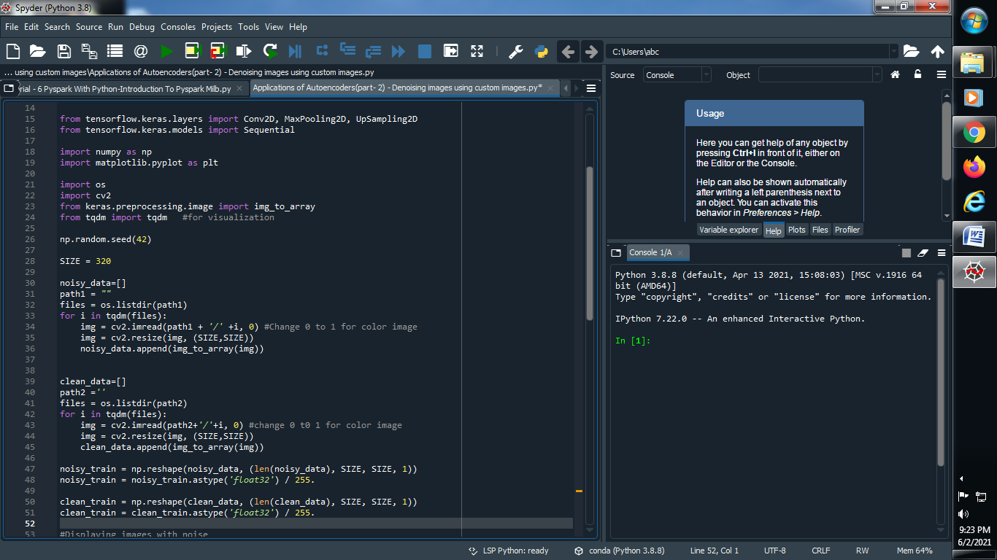

**(4) Give the path of clean images :**

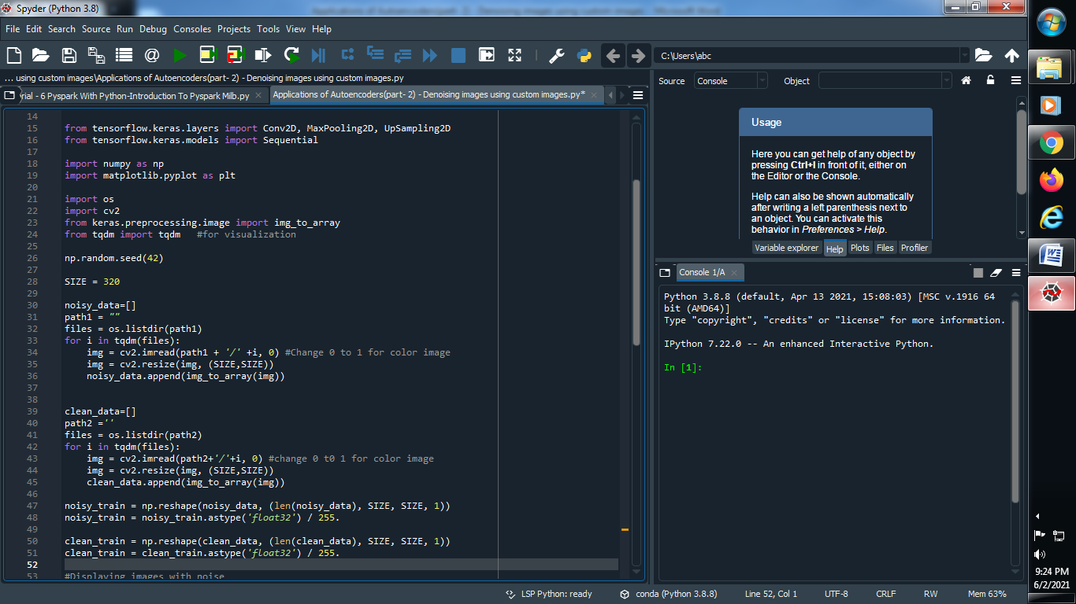

**(5) Reshape our images and convert integer values into floating point values and normalize it :**

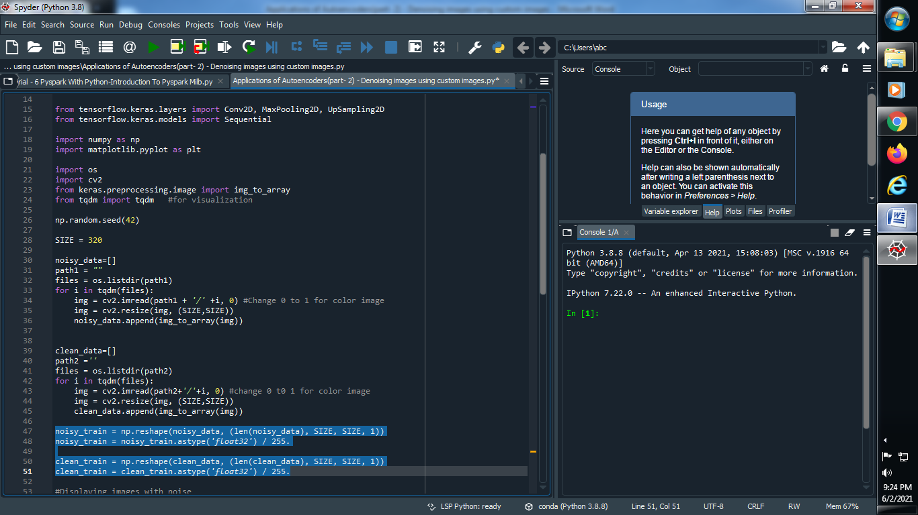

**(6) Displaying images with noise :**

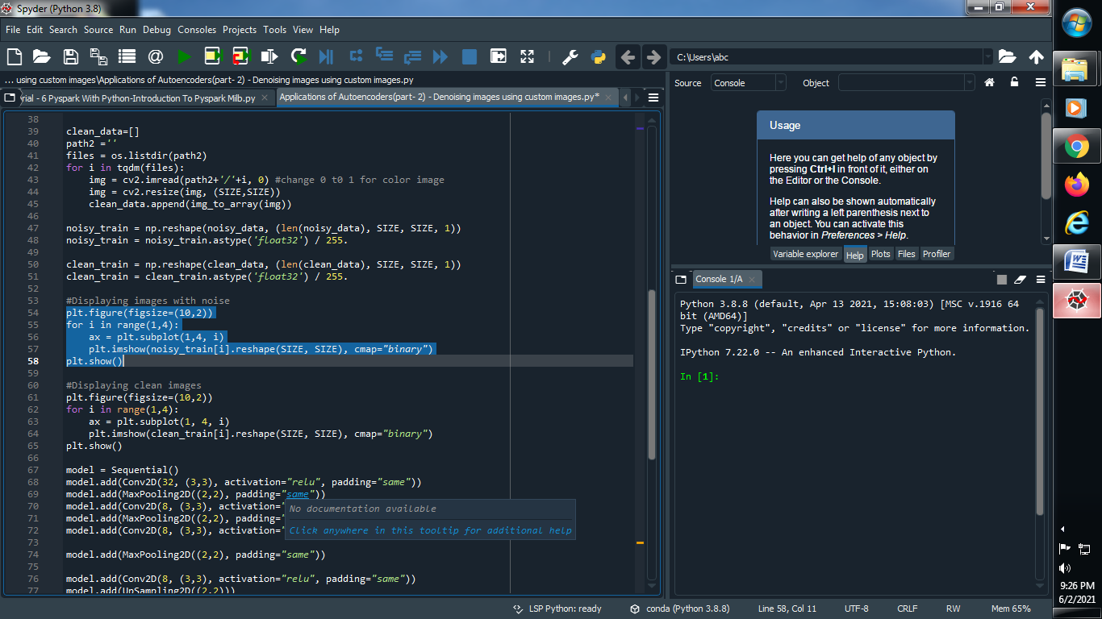

**(7) Displaying clean images :**

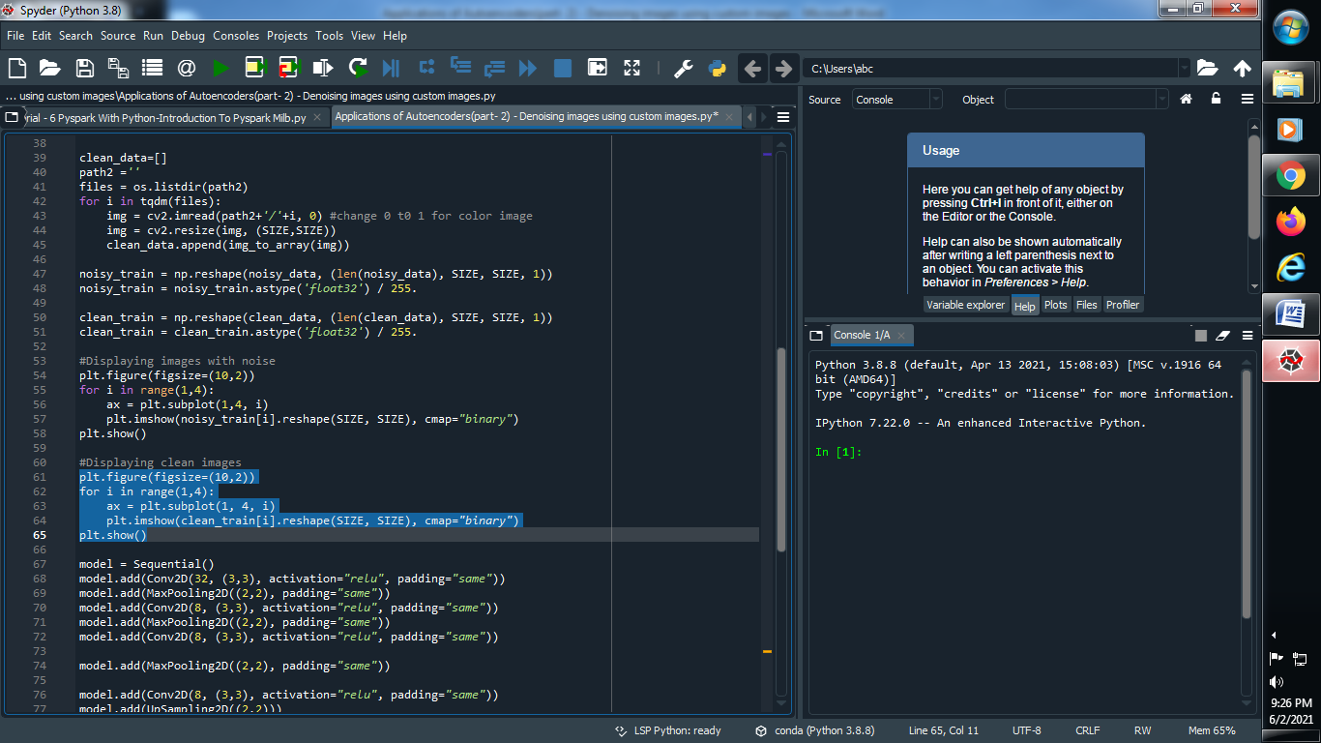

**(8) Create and define CNN model :**

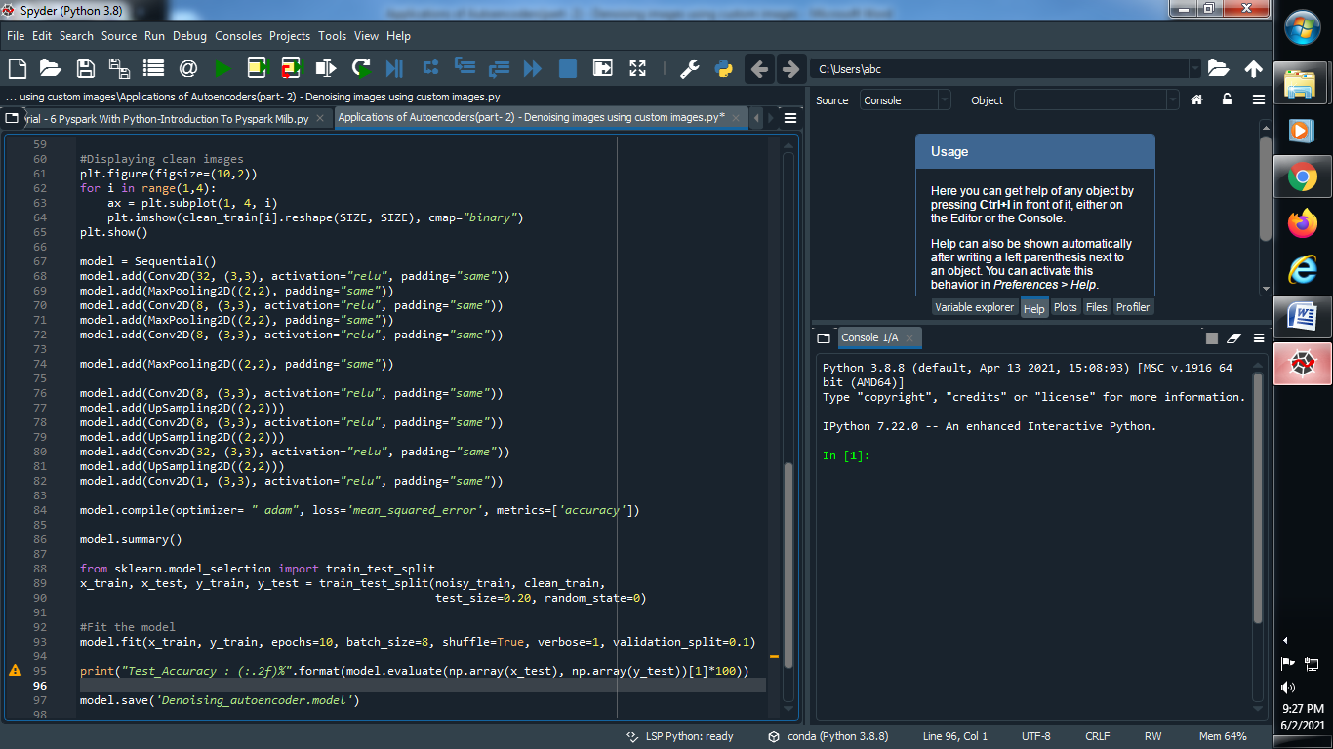

**(9) Split our data into training and testing dataset :**

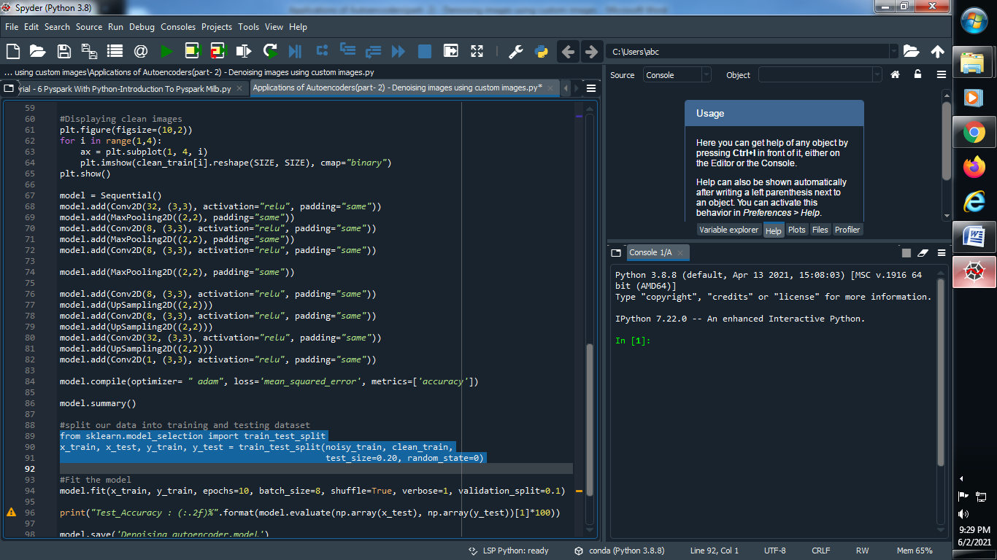

**(10) Fit the model :**

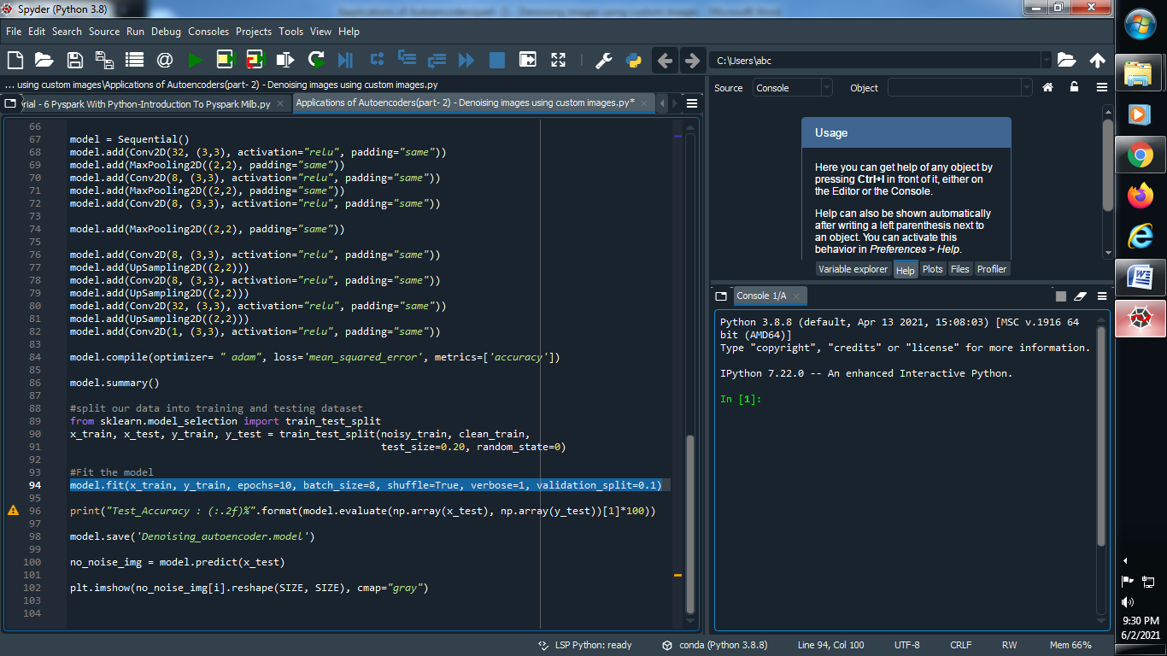

**(11) Find accuracy of our model :**

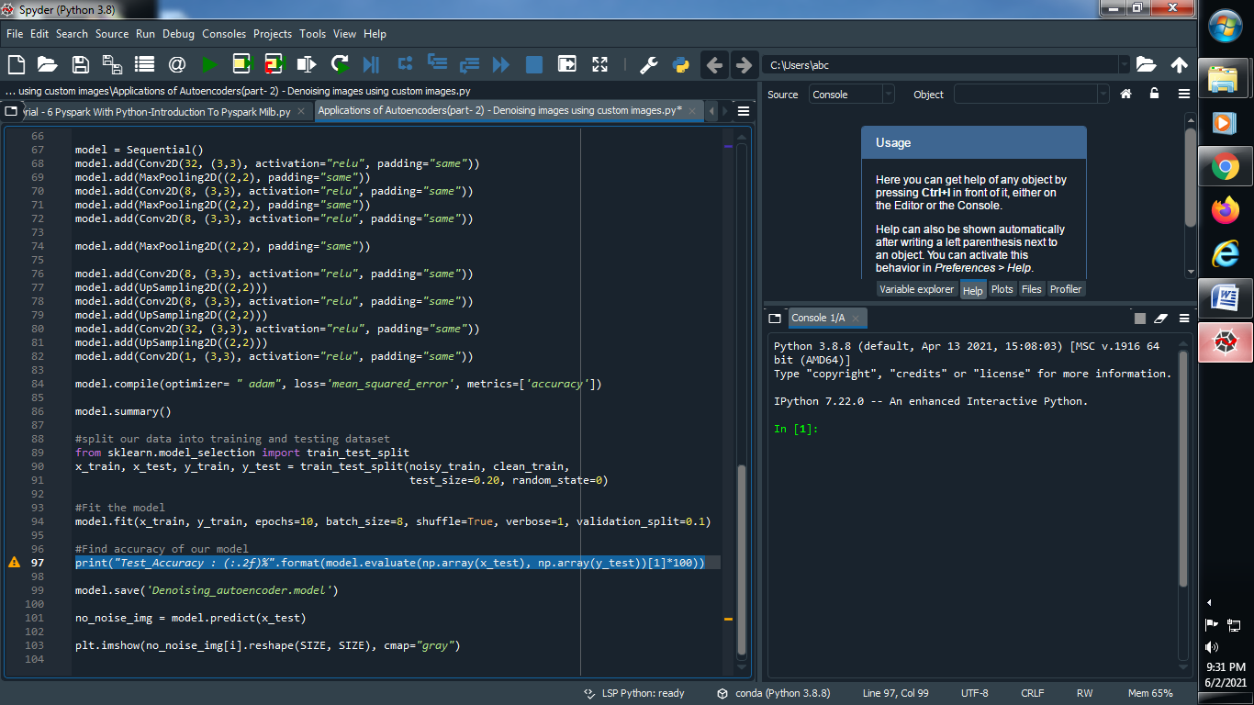

**(12) Save our model :**

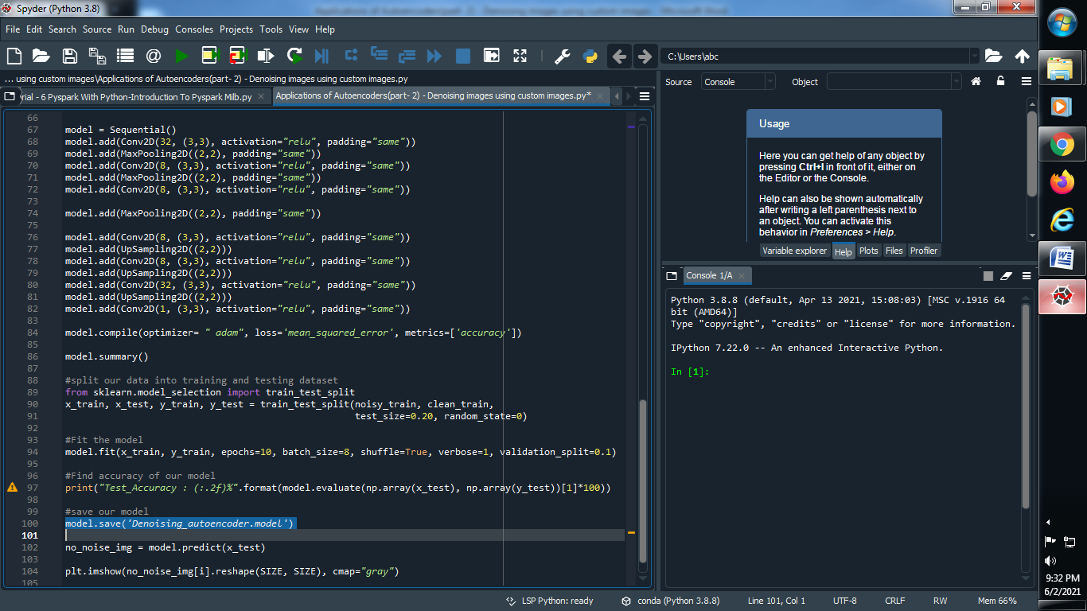

**(13) Predict our model :**

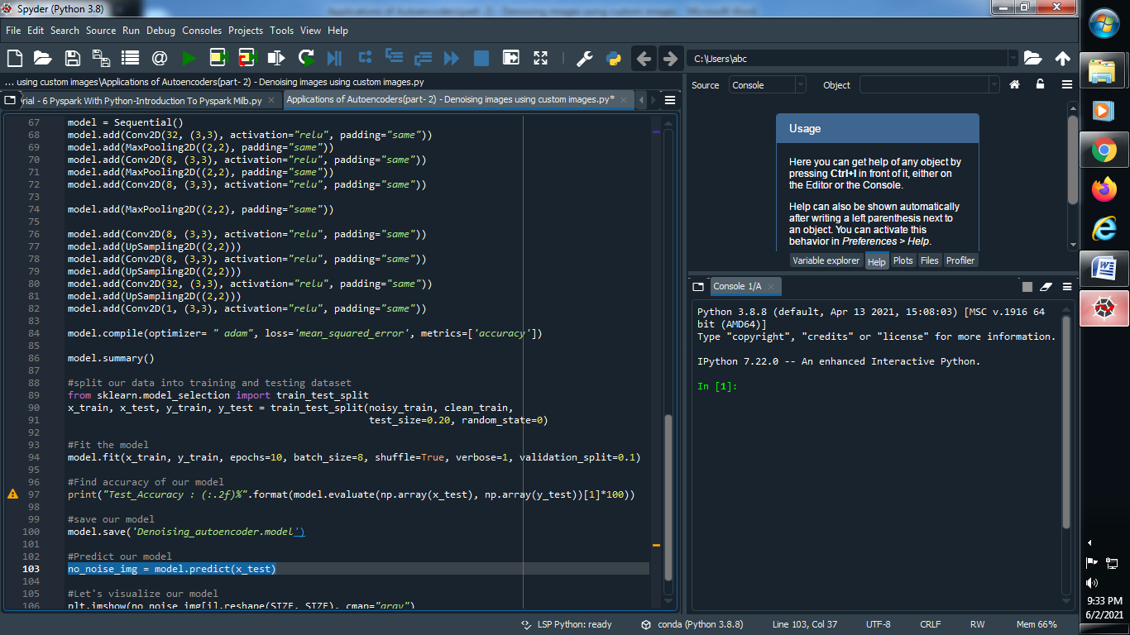

**(14) Let’s visualize our model :**

